# **Lesson 2: Classifying Elements**

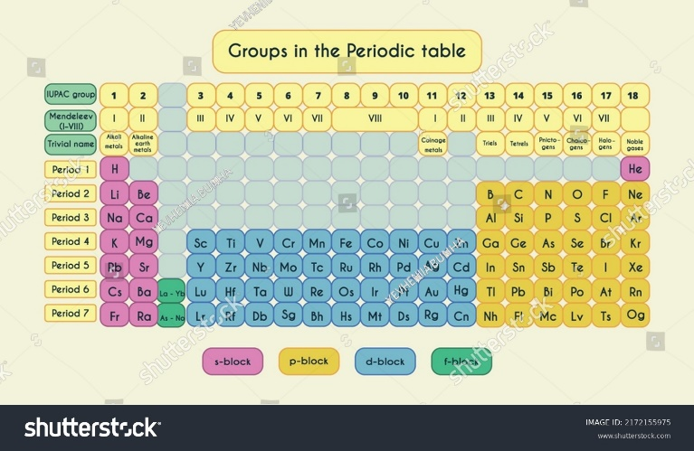

Figure 5.5. Classification of elements in the periodic table

## <H1> **Essential Question**

How do you use the periodic table to predict the properties of elements?

## <H1> **Big Idea**

The periodic table is a chart of elements organized according to their atomic numbers and reoccurring chemical properties.

## <H1> **Lesson Objectives**

By the end of the lesson, I will be able to:

* Identify the different groups and periods on the periodic table.
* Relate the position of an element on the periodic table to its properties.
* Analyze the relationship between electron configuration and the chemical properties of elements.

## <H1> **Curiosity Corner**



Figure 5.6. A tractor spreading salts on a snowy road.

In northern countries where winters are extremely cold, roads and sidewalks often become hazardous due to ice and snow. To make them safer for pedestrians and drivers, road salt is spread to melt the ice. These salts, such as sodium chloride (NaCl), magnesium chloride (MgCl2), and calcium chloride (CaCl2), are made up of different elements, yet they all share something in common – chloride. But what about the elements combined with chloride? Sodium, magnesium, and calcium – what chemical phenomena do they have in common, and how do these phenomena help them work as effective deicing agents?

## <H1> **Key Vocabulary**

Lewis dot structure- A diagram showing an element's symbol surrounded by dots representing its valence electrons, useful for visualizing bonding.

Groups and periods- Groups are vertical columns in the periodic table where elements have similar properties, and periods are horizontal rows where properties gradually change.

Metals- Elements, typically on the left side of the periodic table, characterized by high conductivity, malleability, and the tendency to lose electrons.

Metalloids- Elements with properties between metals and nonmetals located along the “staircase” line on the periodic table.

Nonmetals- Elements generally found on the right side of the periodic table; they tend to gain or share electrons and are often insulators.

Valence electrons- Electrons in the outermost shell of an atom that determine its bonding behavior and chemical reactivity.

## <H1> Ignite: **Valence Electrons and Chemical Behavior**

Valence electrons reside in the outermost shell of an atom and play a key role in chemical bonding. The number of valence electrons of an element plays a crucial role in determining whether it will interact with other elements readily or not.

## <H1> Direct Instruction: **Organization of the Periodic Table**

The ability to predict the chemical properties of these elements comes from the periodic table. When the table was first developed, it transformed our understanding of elements, allowing scientists to predict the chemical, physical, and atomic properties of elements based on their placement. Today, you use the periodic table to identify patterns and understand the properties of elements, including why sodium, magnesium, and calcium ions are effective in keeping roads safe in winter. How does the position of these elements on the periodic table help us understand their properties? Can it help us predict which other elements might be similar?

When scientists began to classify elements, they noticed certain patterns of recurrence. By arranging elements in order of increasing atomic number, they discovered that certain properties repeated at regular intervals, or "periodically." This led to the creation of the periodic table—a chart of elements that not only organizes known elements but also helps to predict the properties of elements that haven't been studied in detail yet.

To understand why elements, behave in a certain recurrence pattern, you need to look at the concept of groups (vertical columns) and periods (horizontal rows) on the periodic table. Elements in the same group have similar chemical properties because they have the same number of valence electrons. Valence electrons play a crucial role in how elements interact with other elements. Understanding where an element is located on the table can give us insight into its characteristics and how it might behave when combined with other elements.

### <H2> **Progress Check 1**

1. How does the periodic table help us to predict similar properties of elements?
2. Why might elements in the same group show similar chemical properties? Do they show similar physical properties?

## <H1> **Pathfinder: Exploring Groups and Periodic Trends**

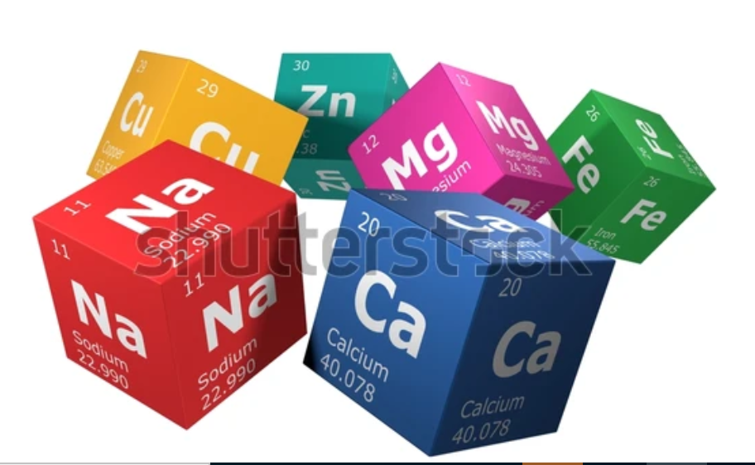

Figure 5.7. Some elements from the periodic table

**Materials Required:**

Periodic table chart

Colored markers

Worksheet for identifying elements' properties

**Procedure:**

1. Locate sodium, magnesium, and calcium on the periodic table. Identify which group and period they belong to.
2. Mark other elements in the same groups as these three. What do they have in common?
3. Explore different blocks, such as the s-block, p-block, d-block, and f-block. Identify trends in properties such as reactivity, and electron configuration.
4. Use the worksheet to summarize the key properties of each group.
5. Use the worksheet to summarize the key properties of each block.

Discuss with your classmates:

1. How do the properties in groups and blocks differ from each other?
2. Lanthanides are elements in the f-block of period 6, located between lanthanum (Z = 57) and hafnium (Z = 72). Is lanthanum a lanthanide?

## <H1> Lightbulb: **Classifying Elements**

How can you predict the properties of magnesium, calcium, and sodium using the periodic table? Here, classification of the elements in the periodic table becomes essential.

The elements are organized into groups (vertical columns) and periods (horizontal rows) in the periodic table based on their atomic numbers. For example, sodium, magnesium, and calcium are all metals, and their position on the periodic table indicates that these elements can donate electrons and become cations that react with anions like chloride to form salts. Let’s explore how the periodic table helps us understand these patterns and what other information it can reveal.

## <H1> **Groups and Periods: Organizing the Elements**

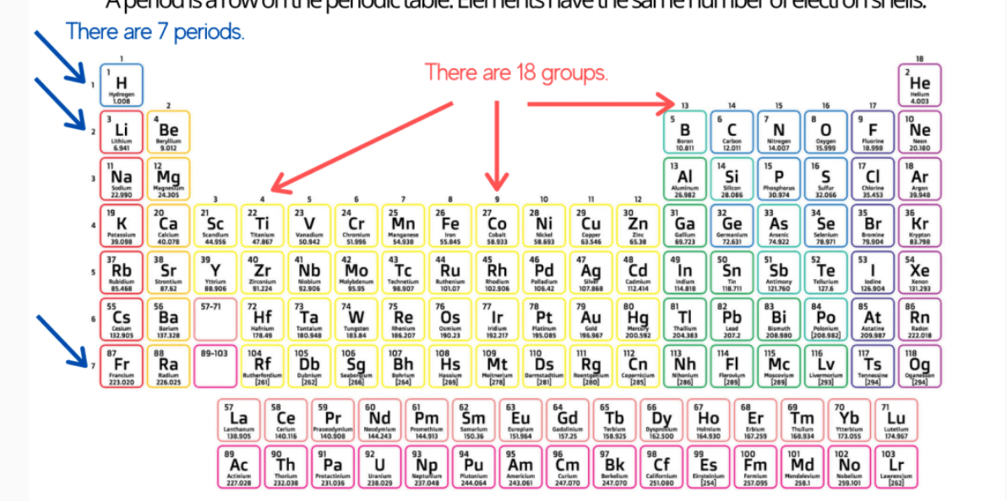

Figure 5.8. The periodic table shows groups in vertical columns and periods in horizontal rows

The periodic table is designed to group elements with similar properties. Groups are vertical columns, and elements within the same group share similar chemical properties because they have the same number of valence electrons – the electrons in their outermost shell. Periods are horizontal rows, and as you move across a period, the properties of elements change gradually, revealing patterns that are essential for understanding chemical behavior.

There are 18 groups and seven periods on the periodic table. Each group helps to identify elements that behave similarly. For example, elements in Group 1, like sodium, are highly reactive metals, while Group 2 contains less-reactive metals than the elements residing in Group 1, such as magnesium and calcium. This pattern repeats across the table, making it easier to predict how different elements might behave based on their position in the table.

### <H2> **Progress Check 2**

How would you expect the properties of an element in Group 1 to differ from those of an element in Group 17? Explain your reasoning.

## <H1> **Metals, Metalloids, and Nonmetals: Types of Elements**

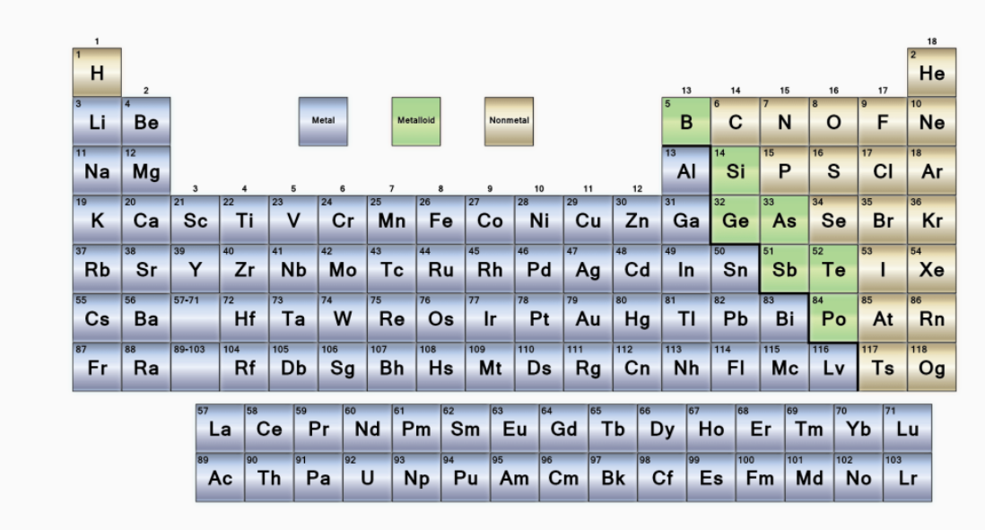

Figure 5.9. Periodic table showing metals, nonmetals, and metalloids

Elements can be broadly categorized as metals, metalloids, or nonmetals, based on their properties.

**Metals:**

The elements found on the left side and center of the periodic table (Groups 1–12 and part of Groups 13–16) are known as metals.

***Characteristics:***

Shiny, good conductors of heat and electricity, malleable, and ductile.

Tend to lose electrons easily during chemical reactions, forming positive ions.

Examples: Sodium (Na), Magnesium (Mg), Calcium (Ca).

**Nonmetals:**

The elements located on the right side of the periodic table, primarily in Groups 14–18, are known as nonmetals.

***Characteristics:***

Dull, poor conductors of heat and electricity, brittle in solid form.

Tend to gain or share electrons in reactions, forming negative ions or covalent bonds.

Examples: Oxygen (O), Carbon (C), Chlorine (Cl).

**Metalloids:**

The elements are found along the staircase line also known as metal–nonmetal line separates metals and nonmetals (including elements like silicon and arsenic) known as metalloids.

***Characteristics:***

Have properties of both metals and nonmetals, making them semiconductors.

Examples: Silicon (Si), Boron (B), and Arsenic (As).

### <H2> **Progress Check 3**

1. Identify whether the following elements are metals, metalloids, or nonmetals: Silicon, Oxygen, and Magnesium.
2. Compare the properties of metals and metalloids. How do these properties influence their use in different industries? Provide examples.

## <H1> Lewis dot structures

Drawing a Lewis dot structure is a simple way to represent the valence electrons of an element. It shows the symbol of an element surrounded by dots; each dot represents a valence electron. This helps visualize which elements might give up electrons from their valence shell or take away electrons from atoms of other elements. Later, you will learn how to use Lewis dot structures to represent chemical bonds.

Steps to Draw a Lewis Dot Structure:

Write the element symbol.

* Determine the number of valence electrons for the element.
* Place one dot for each valence electron around the symbol, starting on one side and moving clockwise.

Example: Drawing the Lewis Dot Structure for Sodium (Na):

The symbol for sodium is "Na."

Sodium has one valence electron.

Place one dot next to the symbol.

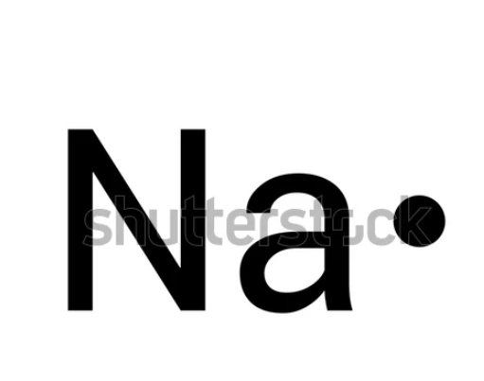

Figure 5.10. Lewis dot structure of sodium

### <H2> **Progress Check 4**

Draw the Lewis dot structure for chlorine.

## <H1> **Power Up**

The Questioneer Icon

Reflect on the following prompts to think critically about the content and come up with meaningful questions for inquiry about classifying elements:

* The pattern or trend of elements on the periodic table is classified with the help of various properties like malleability, reactivity, and conductivity.
* The classification of elements in the periodic table greatly influences their application in industries as well as technology.
* Like an alkali metal, hydrogen (H) has one valence electron, but it behaves like a nonmetal.
* All lanthanides have very similar properties to lanthanum (Z = 57) while all actinides have very similar properties to actinium (Z = 89). How can these similarities be represented in a 3D Periodic Table?
* The periodic table and current classification system may suffer modifications in the future with newly discovered elements that have high atomic numbers.

## <H1> **Lesson Check**

1. If you were asked to find an element that could replace sodium in road salt to melt ice, where on the periodic table would you look for and why?
2. Explain how the position of an element in a group affects its valence electrons and chemical behavior. Provide an example.
3. Compare the properties of metals and nonmetals based on their location on the periodic table. How do these locations help to determine whether an element is a metal or a nonmetal?
4. Magnesium and aluminum are located in adjacent groups on the periodic table. Predict how their properties might be similar or different based on their position and explain your reasoning.
5. Why do elements in the same period show a gradual change in properties as you move from left to right? Describe what happens to atomic size and other properties across a period.
6. Draw the Lewis dot structure for oxygen. Explain how it indicates the number of bonds that oxygen can form with other elements.

## <H1> **Beyond the Lesson**

The periodic table is more than just a chart; it’s a tool that helps us make sense of the elements around us. For example, when creating alloys, manufacturers can predict which metals will mix well together to form strong materials, lightweight, or resistant to corrosion. In medicine, understanding the properties of different elements helps scientists design drugs that can interact effectively with the human body. In environmental science, the periodic table helps us understand how pollutants behave and how they can be neutralized.

Knowing how to read the periodic table enables you to understand not just what elements are, but also how they can be used to solve practical problems.